**A STARTUP ANALYSIS**

**1.Introduction**

**1.1 overview**

Starting a new company can be an exciting and rewarding experience, but it also requires careful planning and analysis to ensure that the business is viable and successful. There are several key areas that you should focus on when conducting a startup company analysis. Conducting a thorough analysis of these areas can help you identify potential challenges and opportunities, and develop strategies to address them.

It is also important to regularly review and update your analysis as the business progresses, in order to adapt to changing market conditions.

**1.2 Purpose**

Startups are the boost for any country. By analysing the startups and number of startups coming every year and industries that are seeing the boom, may somebody with the dilemma to start or not start can start his/her own company and become successful.

Can make this visualization application available for people, for more insights and ideas can ask for payment and also can give these insights to investors and banks to make the understand and help in the sense of investing.

**2. Problem defining and desing thinking**

**2.1**

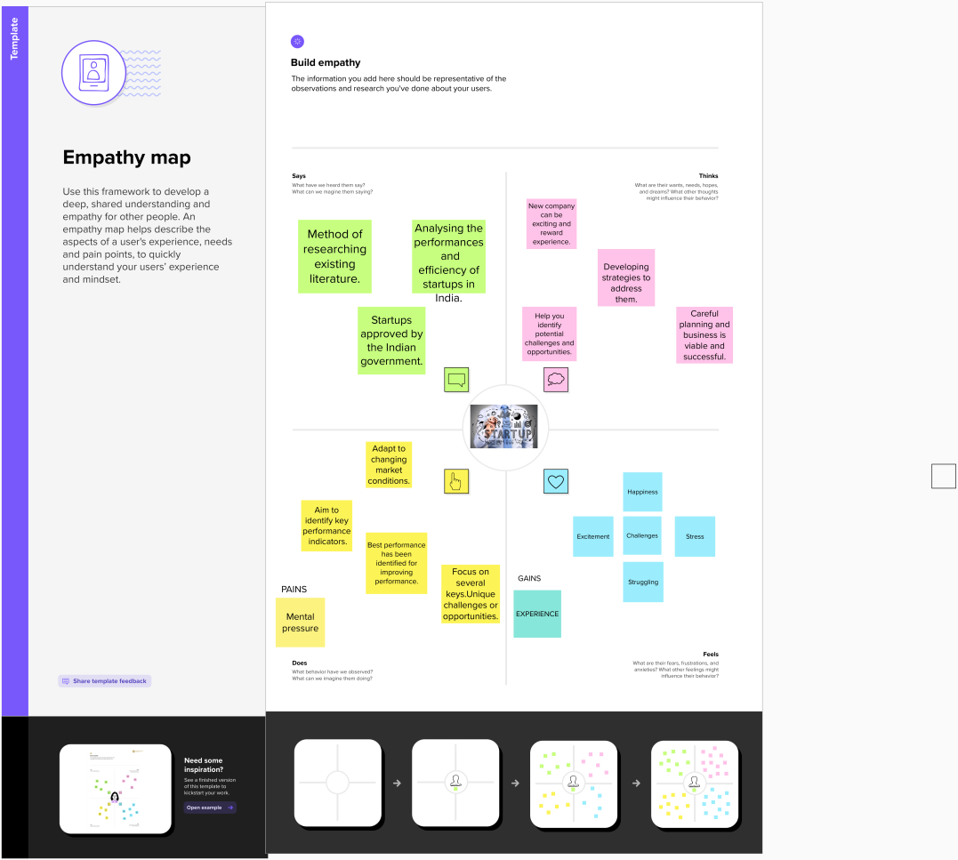

**2.2 Identation and brainstorming**

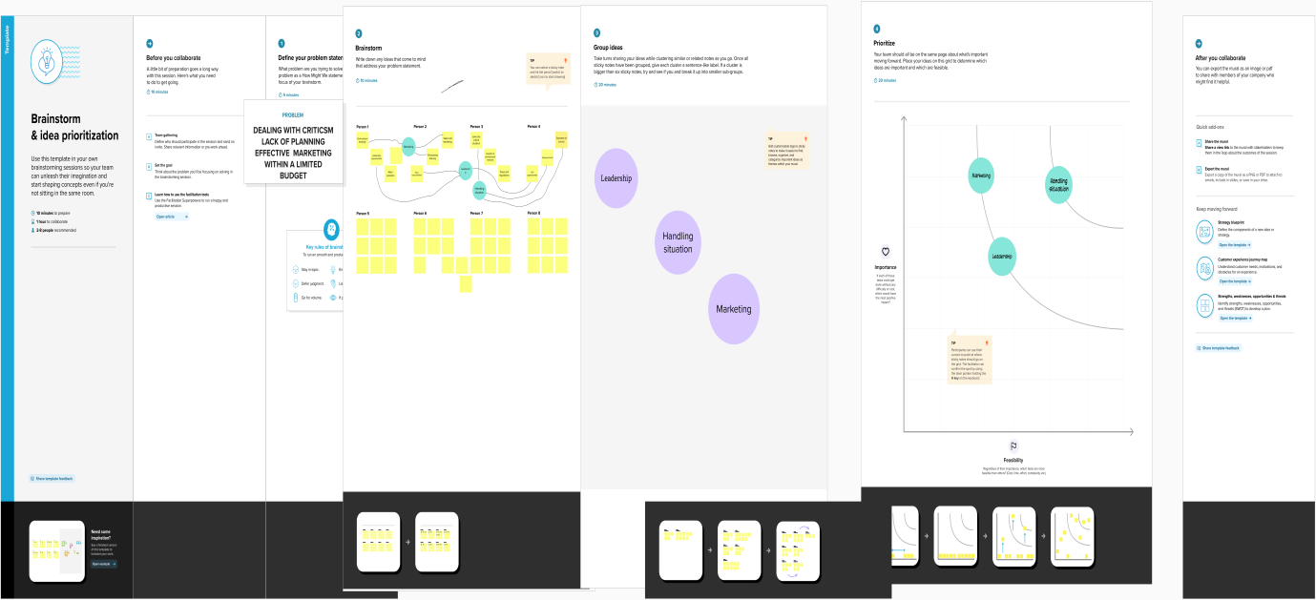

3.**RESULT**

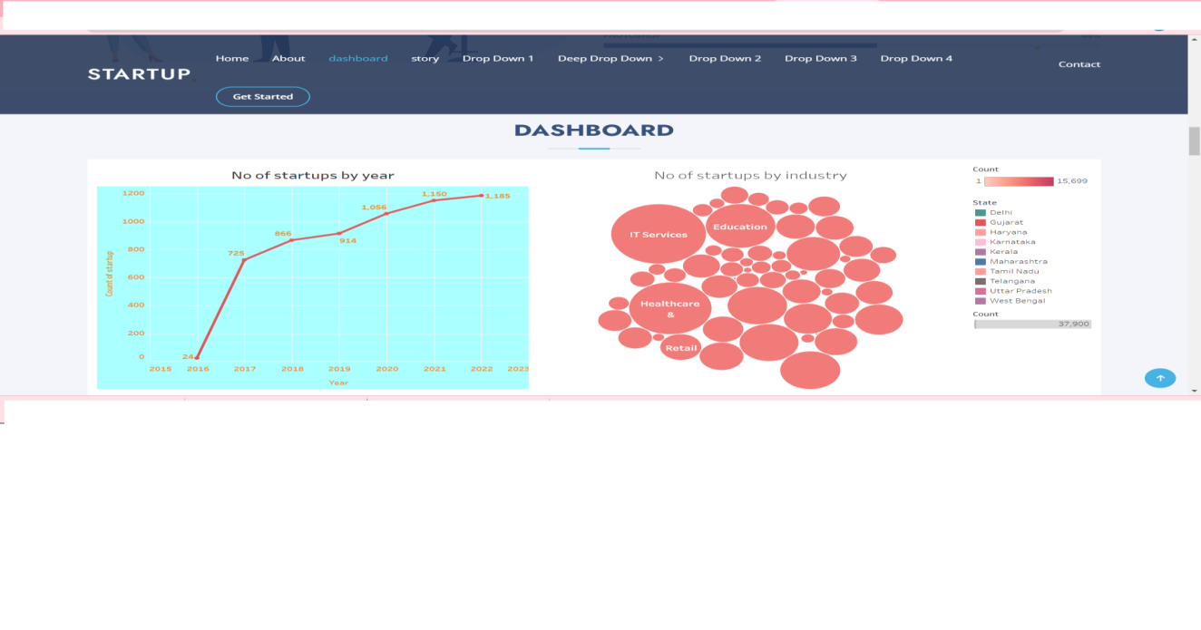

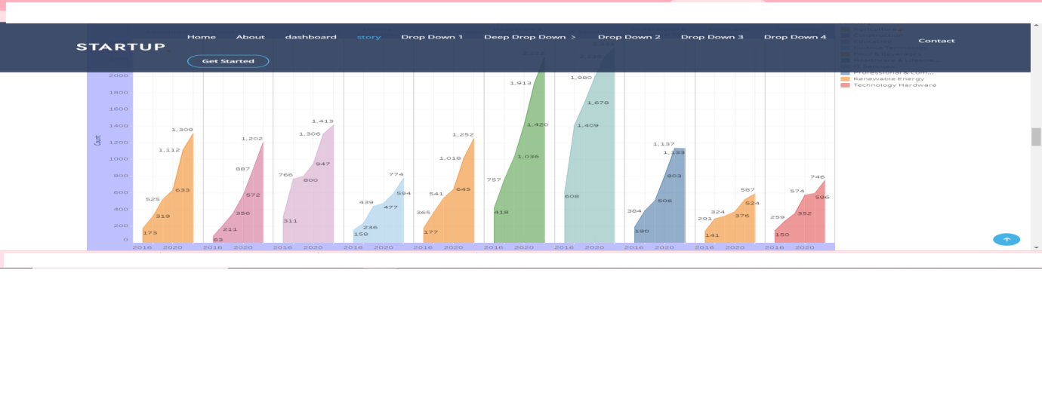

**4.Advantages**

* Tax benefits
* Self certification under labour and environment laws
* Intellectual property rights [IPR] benefits
* Business opportunities
* Rebates

**DISADVANTAGES**

* Uncertain job security
* Long hours
* Less pay
* Lack of structure
* Constant change
* Limited resources
* Too much freedom

**5.APPLICATIONS OF STARTUPS**

It adds value to the startups in certain geographical areas, and which approach of project management is used . It has been concluded from the literature that there are many ways of linking project management because of its flexibility and time efficiency.

* Needs assessment
* Solution design
* Implementation and design
* Evaluation
* Executive summary
* Market analysis
* Marketing strategy
* Financial

**CONCLUSION**

It helps us to make sure that each member of the team has a specific role and responsibility that team members are compatible with each other and can work together harmoniously.

Mainly it is very useful in job security.

**FUTURE SCOPE**

Generally startups in India are expected to raise USD180 billion in 2023,with a growing economy,

a large pool of talented individuals , the scope for Indian startups is immense in various sunrise and sustainable development sectors such as green energy,health tech .

**APPENDIX**

**SOURCE CODE**

<!-- ======= Services Section ======= -->

<section id="services" class="services section-bg">

<div class="container" data-aos="fade-up">

<div class="section-title">

<h2>dashboard</h2>

<div class='tableauPlaceholder' id='viz1681985710920' style='position: relative'><noscript><a href='#'><img alt='Dashboard 1 ' src='https:&#47;&#47;public.tableau.com&#47;static&#47;images&#47;Da&#47;Dahboard_16817223536570&#47;Dashboard1&#47;1_rss.png' style='border: none' /></a></noscript><object class='tableauViz'  style='display:none;'><param name='host_url' value='https%3A%2F%2Fpublic.tableau.com%2F' /> <param name='embed_code_version' value='3' /> <param name='site_root' value='' /><param name='name' value='Dahboard_16817223536570&#47;Dashboard1' /><param name='tabs' value='no' /><param name='toolbar' value='yes' /><param name='static_image' value='https:&#47;&#47;public.tableau.com&#47;static&#47;images&#47;Da&#47;Dahboard_16817223536570&#47;Dashboard1&#47;1.png' /> <param name='animate_transition' value='yes' /><param name='display_static_image' value='yes' /><param name='display_spinner' value='yes' /><param name='display_overlay' value='yes' /><param name='display_count' value='yes' /><param name='language' value='en-US' /></object></div>                <script type='text/javascript'>                    var divElement = document.getElementById('viz1681985710920');                    var vizElement = divElement.getElementsByTagName('object')[0];                    if ( divElement.offsetWidth > 800 ) { vizElement.style.width='100%';vizElement.style.height=(divElement.offsetWidth*0.75)+'px';} else if ( divElement.offsetWidth > 500 ) { vizElement.style.width='100%';vizElement.style.height=(divElement.offsetWidth*0.75)+'px';} else { vizElement.style.width='100%';vizElement.style.height='1427px';}                     var scriptElement = document.createElement('script');                    scriptElement.src = 'https://public.tableau.com/javascripts/api/viz_v1.js';                    vizElement.parentNode.insertBefore(scriptElement, vizElement);                </script>

</div>

</div>

</div>

</section><!-- End Services Section -->

<!-- ======= Portfolio Section ======= -->

<section id="portfolio" class="portfolio">

<div class="container" data-aos="fade-up">

<div class="section-title">

<h2>story</h2>

<div class='tableauPlaceholder' id='viz1682062921496' style='position: relative'><noscript><a href='#'><img alt='Story 1 ' src='https:&#47;&#47;public.tableau.com&#47;static&#47;images&#47;st&#47;story_16817224774380&#47;Story1&#47;1_rss.png' style='border: none' /></a></noscript><object class='tableauViz'  style='display:none;'><param name='host_url' value='https%3A%2F%2Fpublic.tableau.com%2F' /> <param name='embed_code_version' value='3' /> <param name='site_root' value='' /><param name='name' value='story_16817224774380&#47;Story1' /><param name='tabs' value='no' /><param name='toolbar' value='yes' /><param name='static_image' value='https:&#47;&#47;public.tableau.com&#47;static&#47;images&#47;st&#47;story_16817224774380&#47;Story1&#47;1.png' /> <param name='animate_transition' value='yes' /><param name='display_static_image' value='yes' /><param name='display_spinner' value='yes' /><param name='display_overlay' value='yes' /><param name='display_count' value='yes' /><param name='language' value='en-US' /></object></div>                <script type='text/javascript'>                    var divElement = document.getElementById('viz1682062921496');                    var vizElement = divElement.getElementsByTagName('object')[0];                    vizElement.style.width='100%';vizElement.style.height=(divElement.offsetWidth*0.75)+'px';                    var scriptElement = document.createElement('script');                    scriptElement.src = 'https://public.tableau.com/javascripts/api/viz_v1.js';                    vizElement.parentNode.insertBefore(scriptElement, vizElement);                </script>

</div>

</div>

</div>

</div>

</div>

</section><!-- End Portfolio Section -->